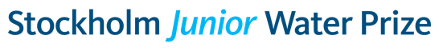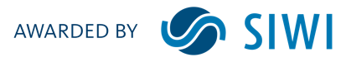

Certificate

The international Stockholm Junior Water Prize competition brings together the world’s brightest young scientists to encourage their continued interest in water and the environment. Each year, thousands of participants in approximately 40 countries join national competitions for the chance to represent their nation at the international final held during the World Water Week in Stockholm.

During their time in Stockholm, winners of the national competitions receive an opportunity to meet and learn from the present leaders of the global water community and make life-long friendships with international compatriots who share a passion for water and science.

Stockholm International Water Institute hereby certifies that XXXX is the national organizer of the Stockholm Junior Water Prize in XXXX

Ania Andersch, Senior Manager,
Stockholm Junior Water Prize

Stockholm International Water Institute, SIWI
Box 101 87 | Stockholm | SE-100 55, Stockholm, Sweden

Visiting Address: Linnégatan 87A

