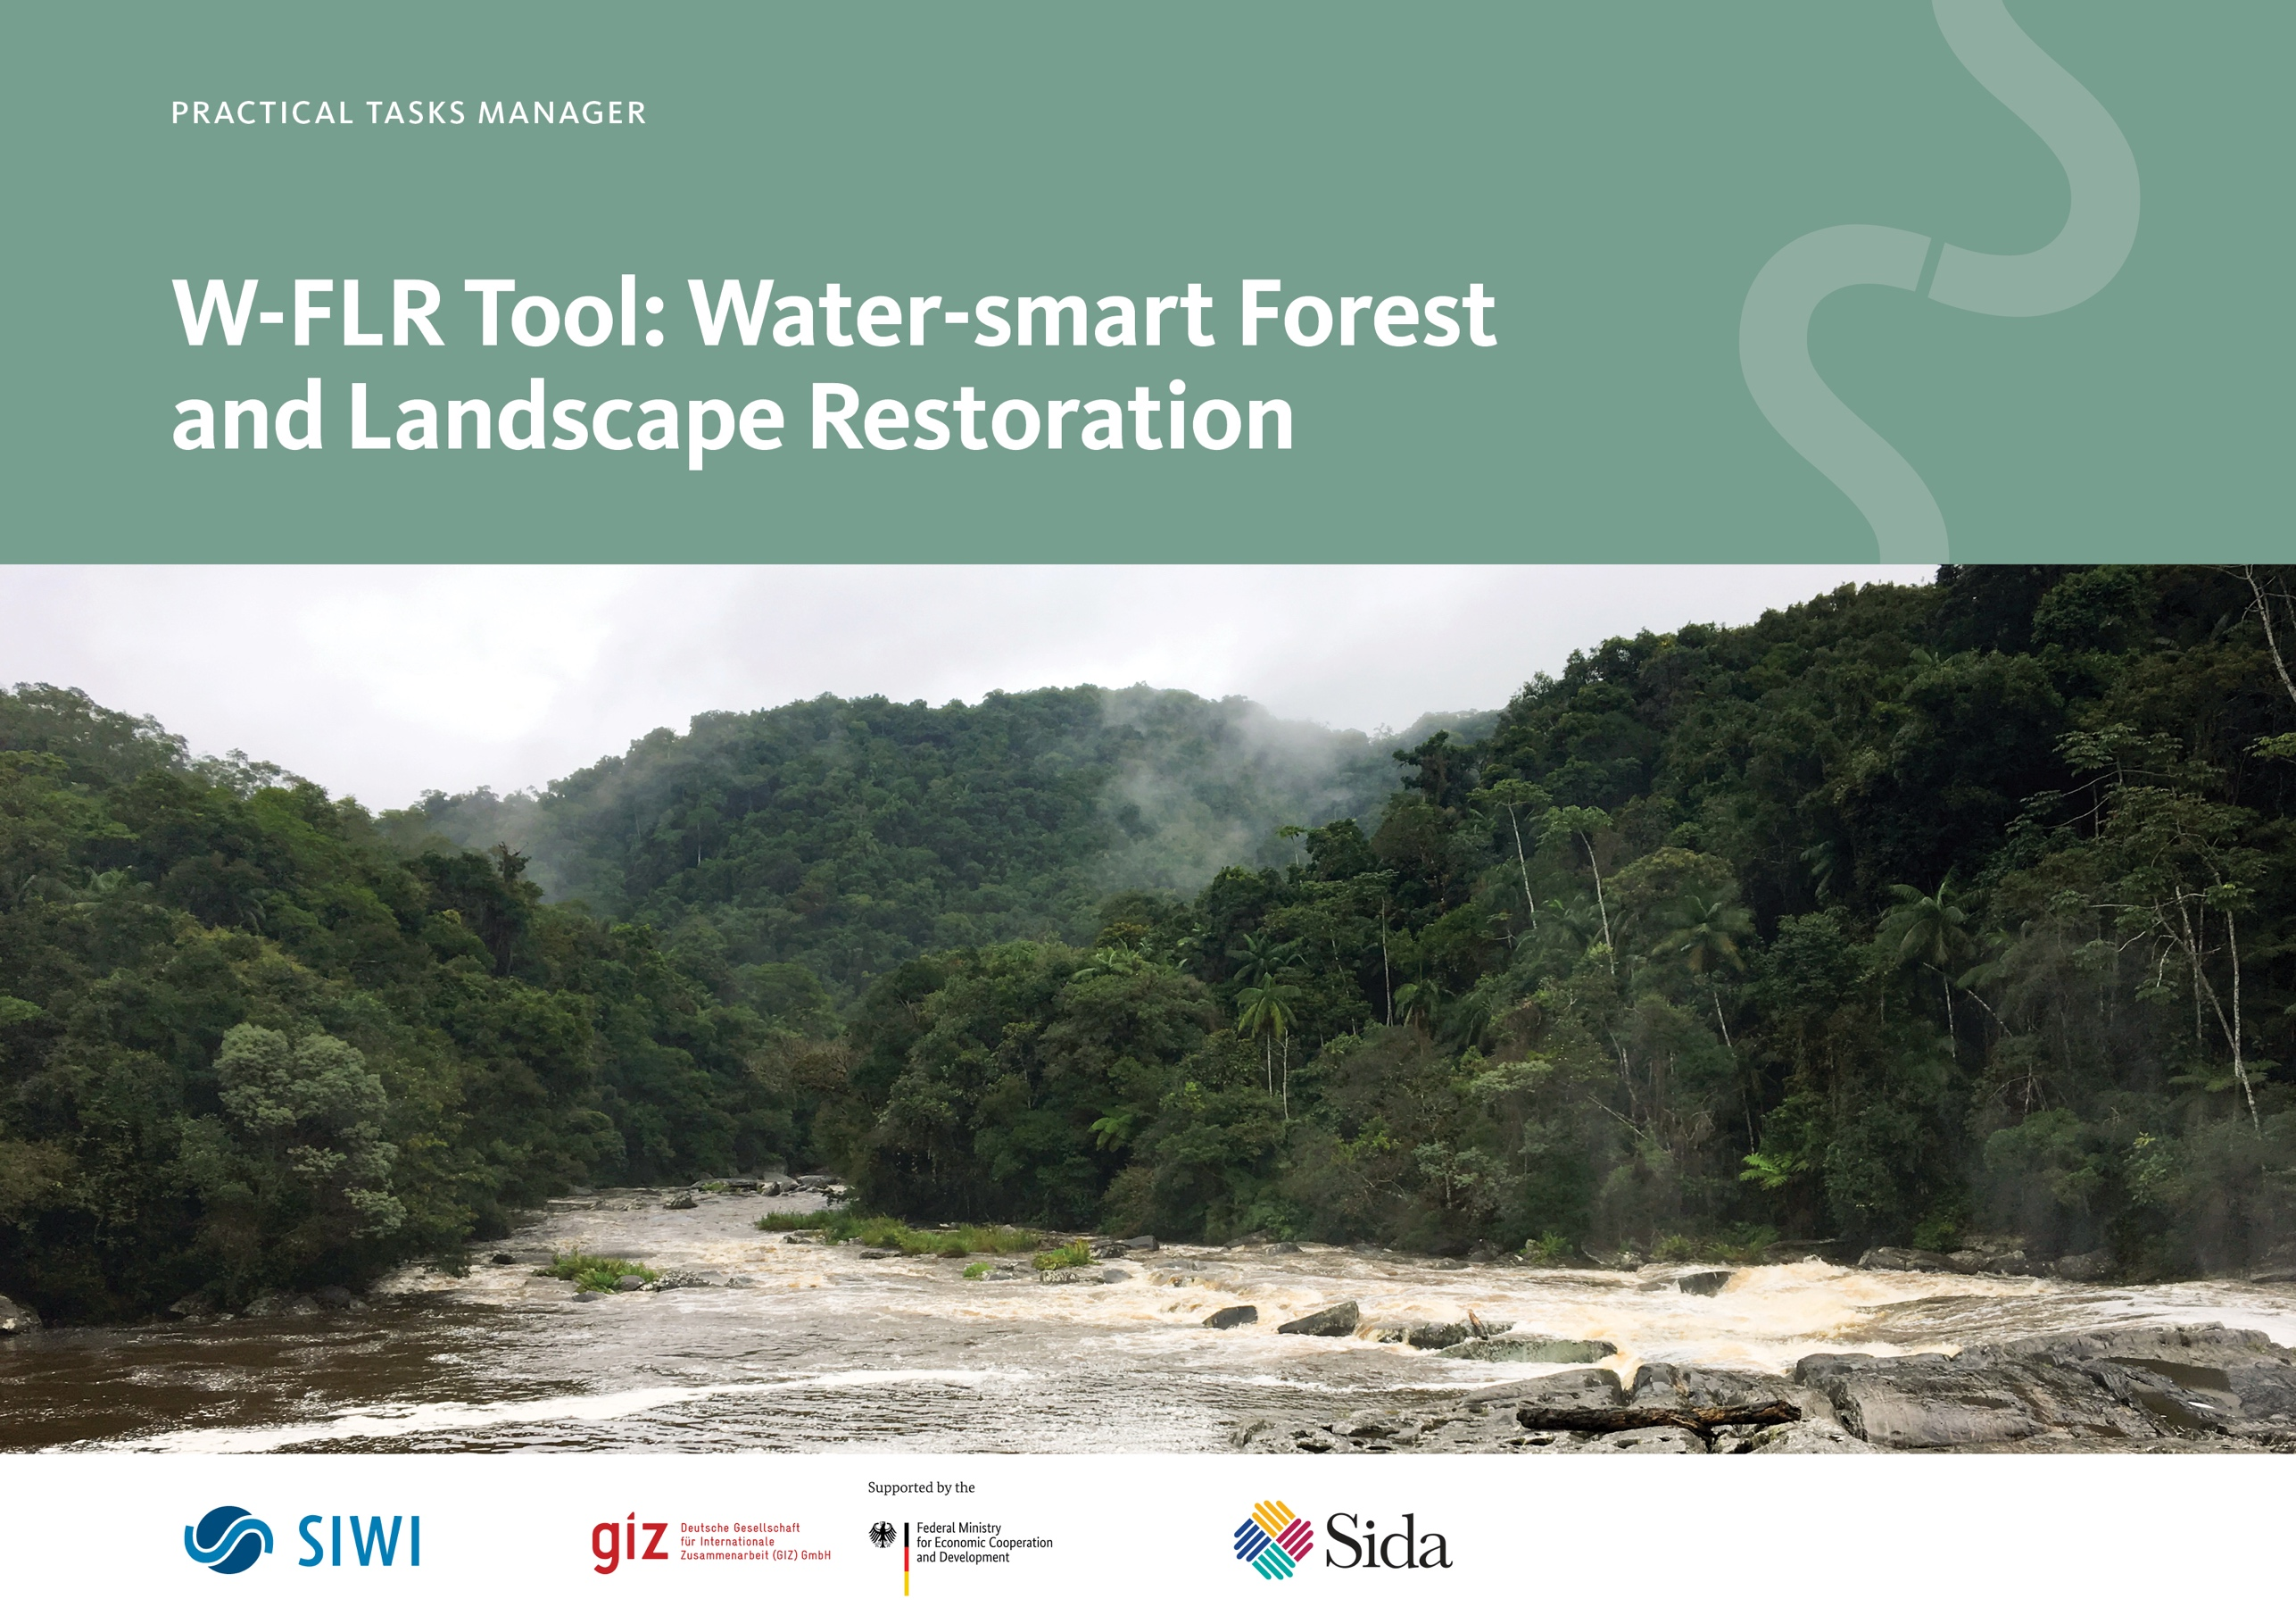

Copyright © 2025, Stockholm International Water Institute, SIWI

How to cite
SIWI 2025. W-FLR Tool: Water-smart Forest and Landscape Restoration, Practical Tasks Manager. Stockholm.
Authored by
Mingasson, D., Lundberg Ingemarsson, M., Tengberg, A.
Cover image
Anna Tengberg
Editing
SIWI
Layout
Picture + Verse
Contact
Stockholm International Water Institute
Kabyssgatan 4D, 120 30, Stockholm, Sweden
Visiting Address: Hammarbybacken 31
Tel. +46 8 121 360 00 • www.siwi.org

Contents
Introduction to the Practical Tasks Manager 4
Module 1: Provide background information on the hydrological unit and identify related risks and opportunities for water-related ecosystem services 6
Task 1a. Provide background information on the system boundary 6
Task 1b. Identify water-related ecosystem services at risk within the system boundary 7
Module 2: Identify and select entry points for water-smart FLR in policies and plans 10
Task 2a. Identify potential entry points for water-smart FLR in national/ subnational policies and plans 10
Task 2b. Extract entry points for water-smart FLR relevant policies and plans 13
Module 3: Engage key sectors and stakeholders 15
Task 3a. Identify stakeholders relevant to the water-smart FLR initiative. 15
Task 3b. Undertake a stakeholder mapping 18
Module 4: Identify priorities and readiness for water-smart FLR 21
Task 4a. Identify current state and priority actions for your water-smart FLR intervention 21
Module 5: Identify indicators for monitoring and evaluation 24
Task 5a. Identify indicators for monitoring and evaluation 24
Module 6: Develop the W-FLR Roadmap 25
Task 6a. Summarise the results from Task 1-5 in a Roadmap 25

Introduction to the Practical Tasks Manager

The Water-smart Forest and Landscape Restoration (W-FLR) Tool has been developed to support practitioners, organizations, and agencies in integrating water considerations into Forest and Landscape Restoration (FLR) initiatives. Designed for use during the UN Decade on Ecosystem Restoration and beyond, the Tool contributes to achieving the Bonn Challenge target of restoring 350 million hectares of land by 2030, as well as other global and regional restoration goals and commitments.

Structured as a handbook with six modules, the W-FLR Tool provides a step-by-step approach to assess water-related risks and opportunities in FLR, ensuring that water is effectively mainstreamed into FLR planning, implementation, and monitoring. It can be applied both to new initiatives and to strengthen existing restoration efforts.
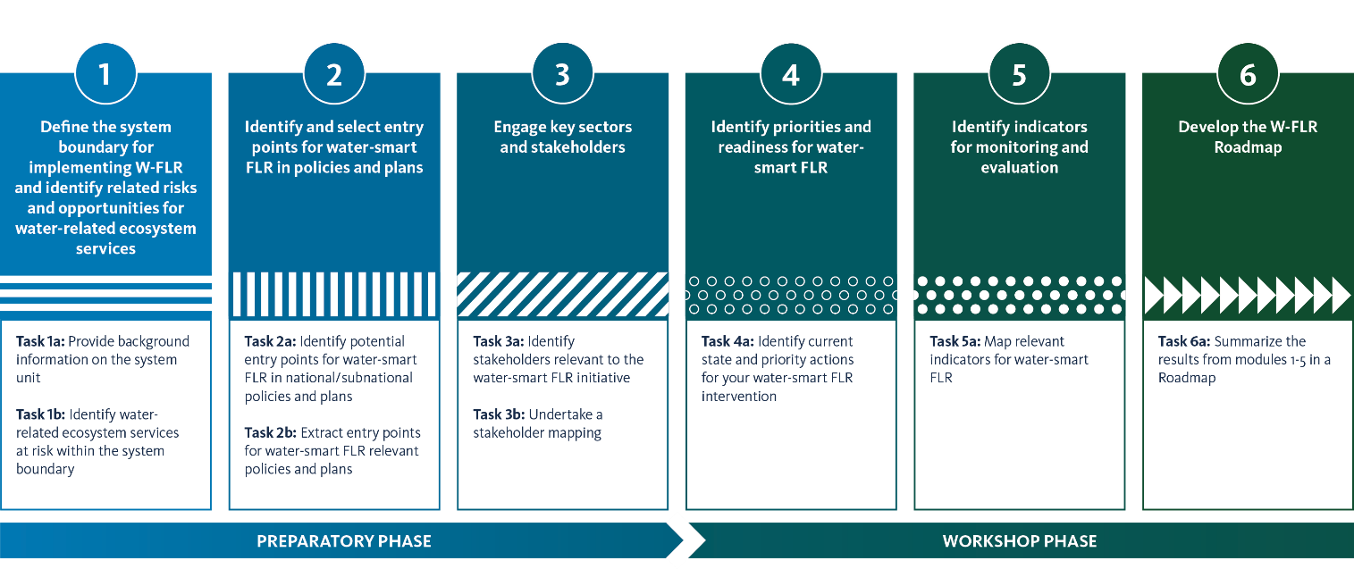

The W-FLR Practical Tasks Manager guides users through the methodology that is described in more detail in the W-FLR Tool Handbook. It entails a preparatory phase, identifying water-relevant ecological functions, ecosystem services at risk and key stakeholders, and a workshop phase for water-smart FLR. The methodology aims at co-creating a W-FLR Roadmap with priority actions for policy mainstreaming, capacity development, and implementation, alongside indicators for participatory monitoring and evaluation.

By bridging the gap between integrated water and forest management, the W-FLR Tool builds on and complements existing methodologies—such as ROAM, and FL-WES—while introducing a clear focus on water as a central element in landscape restoration. Ultimately, this Handbook supports users in advancing inclusive, transparent, and participatory water-smart FLR, ensuring that restored landscapes are more resilient, productive, and sustainable.

Module 1: Define the system boundary for implementing W-FLR and identify related risks and opportunities for water-related ecosystem services

Task 1a. Provide background information on the system boundary

Define the system boundary for the water-smart FLR intervention based on the information on landscapes and system boundaries provided in the Handbook. Optional complementary information on the system boundary can include region, population, population density, surface, length, flow and volume. Try to briefly describe the hydrology of the area. List the key drivers of landscape and forest degradation. Drivers can be categorized in their respective sectors, e.g. forest, landscape, water resources. Finally, identify the potential barriers to restoration and enabling opportunities for restoration. Fill in your answers in "Table 1. Background information on the system boundary" below.

Table 1. Background information on the system boundary
BACKGROUND INFORMATION ON THE SYSTEM BOUNDARY
System boundary
Location, villages, districts, municipalities, population, width, flow, length, area, etc.
Ecological and hydrological description
Key drivers of forest and landscape degradation

Potential barriers to forest and landscape restoration
Enabling opportunities for forest and landscape restoration

Task 1b. Identify water-related ecosystem services at risk within the system boundary
In this task, identify water-related ecosystem services at risk of being reduced or lost within the system boundary. To this end, as ecosystem processes are interlocked in the ecosystem services, focus on ecosystem processes which will, ultimately, reflect the status of ecosystem services.

The aim of the task is to identify which ecosystem processes are at risk due to ecosystem degradation. Assess the ecosystem processes at risk, based on your knowledge and experiences, to further be able to prioritize actions for restoration (Module 4). This assessment is qualitative (no measurement required) and can be adjusted during the application of the Tool.

Mark the degree of risk to the ecosystem processes as follows in “Table 2. Synthesis of water-related ecosystem services”:

Tips:
- Start by using your own expert knowledge of the status of the restoration area. Note that this is a qualitative assessment.
- If necessary, turn to local populations or forest/landscape/water resources experts at hand to gather information on the current status of ecosystem processes.
- If you still wish for more help with the assessment, turn to the W-FLR Helpdesk which can guide you.
Table 2. Synthesis of water-related ecosystem services
WATER-RELATED ECOSYSTEM SERVICES | EXAMPLES OF ECOSYSTEM PROCESSES SUPPORTING THE SERVICE | TASK 1B: CURRENT STATUS OF WATER-RELATED ES | TASK 2B: ADDRESSED IN RELEVANT PLANS AND POLICIES
Supporting ecosystem services
Supporting hydrological cycle | Transpiration. Trees impact water availability by extracting water from the soil or groundwater and emit it to the atmosphere as vapour. With the right management, it can improve local scale atmospheric moisture and green water flows.
Supporting hydrological cycle | Canopy interception. Forest cover/tree canopy reduces the speed of falling rainwater on the surface of the forest floor, potentially reducing surface runoff and erosion.
Supporting hydrological cycle | Hydraulic redistribution. During dry periods with low transpiration (e.g. night or high humidity), deep-rooted trees can improve soil moisture by passively redistributing water from moist to dry soil layers via their roots.
Supporting hydrological cycle | Terrestrial moisture recycling. Forests recharge atmospheric moisture and influence cloud formation, driving (pumping) atmospheric moisture flows from the coastline in over continental interiors which can enhance in-land precipitation.
Supporting nutrient cycling | Water supports the cycling of soil nutrients (e.g. nitrogen and phosphorus) in forest soils from organic materials (living and dead) and minerals in soils and rocks, and from nutrients transported in the flowing water. Tree roots also lock the nutrients in the soil, preventing nutrient leaching into rivers and streams.
Supporting soil formation/quality | Tree roots and soil organic matter from litter inputs (e.g. dead leaves) improve soil structure, slow down water movement and promote faunal activity.
Supporting biodiversity | Forest water creates habitats that safeguard ﬁsheries and biological diversity. Flowing water in forests supports primary production, carrying capacity and niche formation, water also enables dispersal of organisms, pollen and propagule.
Provisioning ecosystem services
Provision of food and medicines | Water is essential for forests to provide the conditions for growing and harvesting food and extracting medicines, e.g. from fruits, mushrooms or bark.
Provision of wood, fibre, energy and fuel | Water is essential for forests to provide wood-related materials for construction, production, energy and fuel including textile, biofuels and plant oils.
Regulating ecosystem services
Water purification | The litter layer on the forest floor, made of fallen leaves, needles, and branches, absorbs and filters out excess nutrients and sediment from e.g. rainwater and agricultural runoff. As rainwater moves through the forest soil, the soil particles and the root systems filter out sediment, bacteria, and pollutants like nitrates, phosphates, and pesticides.
Regulate water flow | Infiltration. Forest and trees impact the entry of water into soil, controlling forest floor runoff and soil and groundwater recharge which can regulate soil moisture and hydrological flows. In dry soils, the tree roots break through the hard surface and open passages where water can seep into the soil.
Regulate water flow | Stem water storage. Trees store water, allowing them to maintain high transpiration for some periods even when uptake from the soil is limited; this allows trees to emit vapour over more extended periods, thus influencing atmospheric moisture.
Flood and erosion control | Forests intercept and store water, slowing runoff and reducing flood peaks. They also stabilize soil with roots, preventing erosion and landslides.
Climate regulation | Reducing local temperature and soil evaporation. Forest and trees return energy and moisture to the atmosphere and create microclimates under tree canopies, thereby cooling the land surface and promoting precipitation.
Climate regulation | Carbon sequestration and storage. Water plays a key role in maintaining forests’ carbon uptake and safeguarding already sequestered carbon.
Cultural ecosystem services
Heritage value and cultural identity | Landscape-related ‘‘memories’’ from past cultural ties, mainly expressed through characteristics within cultural landscapes.
Spiritual experiences | Holy or spiritual places important to spiritual or ritual identity, e.g. River Ganges in India, sacred forest groves, sacred plants or animals.
Wellness, recreation and (eco)tourism | Pleasure, comfort, discovery and socialisation that takes place in leisure in nature and observing natural elements.
Education and research | Climate, topography, water cycle or soil and biota used for education and research.
Aesthetic appreciation and inspiration | Visual perception of ecosystems and landscape.
Aesthetic appreciation and inspiration | Lakes and rivers represented in songs, poetry, paintings, etc.

Module 2: Identify and select entry points for water-smart FLR in policies and plans

Task 2a. Identify potential entry points for water-smart FLR in national/subnational policies and plans

The aim of this Task is to provide overall comments reflecting on the composition of the plans. You can assess both the presence of forest-water links, and the mention of water resources in mitigation and/or adaptation objectives in the NDC.

We suggest that you follow these steps to fill in “Table 3. Identification of potential entry points in national/subnational documents”:

- Review the table of contents in the documents (to assess which sections are relevant).
- Search through the document to collect objectives/measures/actions/projects/programs which may have an impact on the water-smart FLR intervention, related to 1) natural water resources and associated sectors and 2) the forest-water nexus.
- Use the concepts explained in “Table 2. Synthesis of water-related ecosystem services” to identify relevant water-related ecosystem services/processes.
Note that ecosystem processes might not be mentioned as detailed in the national documents, as they are in Table 2, or they may be addressed using a different type of wording. Therefore, remain flexible when you map water-related ecosystem services in the documents, but be careful to not add personal interpretations.
- Identify responsible ministries/agencies
- Provide overall comments reflecting on the composition of the plans regarding the presence of a forest-water nexus and the mention of water resources

Use search words to be more efficient in the review process.
Examples of search words: water, hydro(logy), flood, drought, IWRM, water security, forest(s/ry), restoration, ecosystem services, specific words to your system boundary, i.e., river basin, watershed, riparian, land degradation, plantation, Forest and Landscape restoration, FLR, agroforestry.

Table 3. Identification of potential entry points in national/subnational documents
TYPE OF POLICY OR PLAN |  | COMMENTS
Title | Commitments or measures in plan
Title | Responsible national ministry or agency
Title | Water-related ecosystem service and processes in document

Title | Commitments or measures in plan
Title | Responsible national ministry or agency
Title | Water-related ecosystem service and processes in document

Title | Commitments or measures in plan
Title | Responsible national ministry or agency
Title | Water-related ecosystem service and processes in document

Title | Commitments or measures in plan
Title | Responsible national ministry or agency
Title | Water-related ecosystem service and processes in document

Task 2b. Extract entry points for water-smart FLR relevant policies and plans
Task 2b is based on your findings in Task 1b, where water-related ecosystem services at risk within the system boundary were defined, and Task 2a, where you identified support for water-related ecosystem services in national and sub-national policies and plans.

The objective of this task is to combine results from Task 1b and Task 2a to identify the type and status of water-related ecosystem services mentioned in the different policies and plans collected in Task 2a. Enter the information in "Table 2. Synthesis of water-related ecosystem services", in the furthest column to the right, named Task 2b.

Make an overall comment analyzing and linking Task 1b and Task 2b.

Tips:
First, the overall comment must reflect on the composition of the policies and plans:
- Type of water-related ecosystem services (supporting, provisioning etc.) that are addressed directly or indirectly in policies and plans.
- Number of water-related ecosystem processes or services addressed in policies and plans.
- Water-related ecosystem services at risk considered in policies and plans.

Second, the comment should focus on the type of water-related ecosystem services that are underrepresented in policies and plans and are at risk.

Module 3: Engage key sectors and stakeholders

Task 3a. Identify stakeholders relevant to the water-smart FLR initiative.

In this task, map relevant sectors and stakeholders by making a list covering those having a potential role in your water-smart FLR intervention. Include actors that have influence on and/or are interested in restoration, but also stakeholders that are affected by it. "Table 4. Potentially relevant stakeholders" below is not an exhaustive list, and other additional stakeholders may be involved. The “explanation” column is optional and can be used to describe the potential role of stakeholders. Pertinent stakeholders will be invited to the workshop.

Aim at ensuring inclusivity and representativeness of all relevant groups, including women, youth, and indigenous peoples. In the comment box at the end of “Table 4. Potentially relevant stakeholders”, indicate if you have faced any challenges in this regard and reflect on gender inclusivity and the representativeness of vulnerable groups in your selection.

Table 4. Potentially relevant stakeholders
STAKEHOLDER SECTORS: | SPECIFY (E.G. NAME OF ORGANISATION, AREA OF WORK, CONTACT INFORMATION): | EXPLANATION (OPTIONAL)
National level
National ministries and regulatory agencies (e.g., Forestry, Agriculture, Environment, Climate, Energy, Water)
Non-Governmental Organisations (NGOs)
Universities and research institutes
Certification schemes
Other
Regional/sub-national level
Regional entity
Basin organisations
Regional bureaus/Councils
Other
Local/ district level
District authorities and their technical agencies (e.g. agricultural extension)
Local communities
Women associations

Youth associations
Indigenous groups
Water user associations
Forest/smallholder associations
Farmer cooperatives
Locally active NGO’s
Other

Private sector
Value chain actors (Producers, processors, marketers, etc.)
Local plantation companies
Other
Comments:

Task 3b. Undertake a stakeholder mapping

Use “Figure 1. Stakeholder mapping” below to classify the actors that are relevant in your water-smart FLR initiative according to interest and influence. By knowing who has the influence to make change and who has the interest to make change you can identify how to engage with the different categories of actors. Make sure to involve the stakeholders that are affected by the water-smart FLR initiative, identified in Task 3a.

- Upper left box: Actors with high influence/power but low interest are crucial for the change process to happen and should be targeted to develop their interest or capacity.
- Upper right box: Actors with high interest and high influence/power can be teamed up with in partnerships to work towards the intended goal.
- Lower right box: Actors with high interest but low influence can be used as influencers to raise the interest among actors with low interest and high influence.
- Lower left box: Actors with low interest and low influence/power can often be ignored. However, keep monitoring them to notice any potential changes in future interest or influence.

Based on the results of the Stakeholder mapping, use “Table 5; Selected stakeholders for the workshop”, to select relevant stakeholders to invite to the workshop based on the stakeholder mapping. Aim for meaningful inclusivity and representativeness of all groups, especially youth, women and indigenous people. In the comment box, reflect on your effort on inclusivity and representativeness.

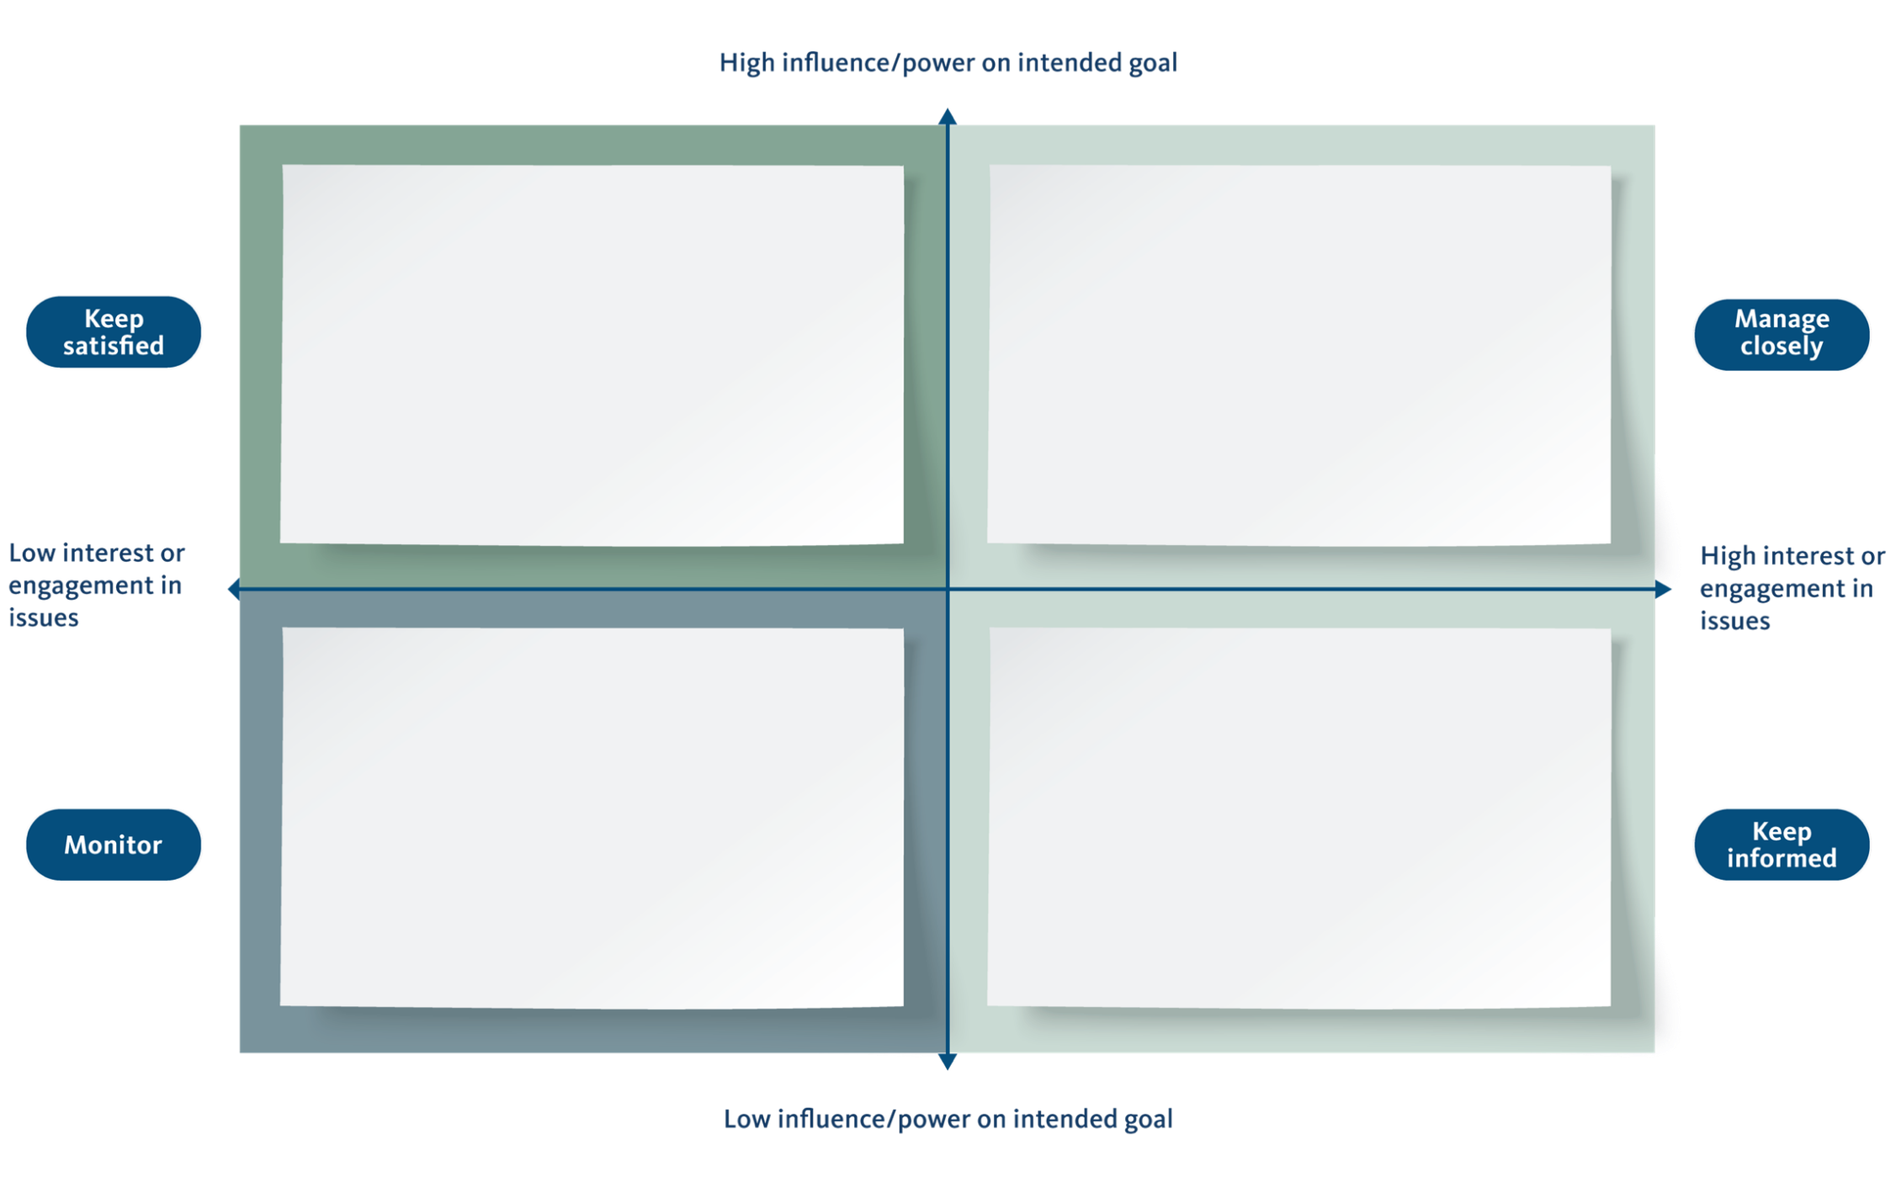
Figure 1. Stakeholder mapping

Table 5. Selected stakeholders for the workshop
N° | STAKEHOLDERS | SECTORS | NUMBER OF PARTICIPANTS
1
2
3
4
5
6
7
8
9
10
11
12
13
14
15
Comments (e.g efforts/ challenges to ensure inclusivity, representativeness):

Training – National stakeholders
Once you have completed the preparatory phase, we recommend organising a training (it can be in-person or online) with national stakeholders to introduce the W-FLR Tool and present the results from Modules 1 to 3. The purpose of this training is to validate the results in the preparatory phase and discuss current national objectives, policies, and plans regarding water-smart FLR interventions. It can further be useful to provide inputs to local stakeholders on the current work and vision at national scale.

The process is now entering the Workshop Phase, and it is time to plan for the workshop and invite the relevant stakeholders identified and mapped in Module 3. Before the workshop, prepare the material from the preparatory phase to be presented to W-FLR stakeholders. An instruction for planning the workshop is found in Module 4 in the W-FLR Handbook.

Module 4: Identify priorities and readiness for water-smart FLR

Task 4a. Identify current state and priority actions for your water-smart FLR intervention
Together with workshop participants, identify priority actions for water-smart FLR related to 1) policy mainstreaming, 2) capacity development, and/or 3) implementation, to gain an overview of the readiness for water-smart FLR within your system boundary. The actions should be based on the results and facts compiled from Module 1-3, including water-related ecosystem services at risk, the aim of the project, as well as participants’ experiences, knowledge and suggestions. Use paper notes during the workshop and then, report the various actions in "Table 6. Priority actions and indicators for your water-smart FLR interventions" below.
Guide the discussion and help the participants sort actions, and if necessary, narrow down the proposed activities under the most relevant pillar. Some actions may involve activities that are relevant to more than one pillar, thus, ensure clarity of the actions with participants.
After outlining the actions, the next step is prioritization, where participants will vote to determine the most urgent and relevant actions. Distribute five stickers to each participant, and the latter needs to place stickers on actions that are most important to them across the different pillars. Participants are allowed to place two or more stickers on the same action to strengthen their vote.
Once the workshop is finalized, interpret and adjust these findings in conjunction with the outcomes from previous Modules and input from local experts to ensure a comprehensive analysis.

Tips:

- Actions must align with the needs identified in Module 1-3 and relate to water-smart FLR.
- Actions must follow a holistic approach to also preserve low-risk ecosystem services. These may come under increasing risk with escalating climate change or land-use change.
- Actions must consider water resources. If not, kindly ask participants to revise their actions
- Ensure that participants vote for actions across pillars and not within each pillar
- Ensure that women, youth and other relevant marginalized groups are involved in the process of elaborating of actions

Table 6. Priority actions and indicators for your water-smart FLR interventions
TASK 4A: PRIORITY ACTIONS | POLICY MAINSTREAMING OF WATER-SMART FLR | CAPACITY DEVELOPMENT IN WATER-SMART FLR | IMPLEMENTATION OF WATER-SMART FLR | TASK 5A: INDICATORS
Action 1
Action 2
Action 3
Action 4
Action 5
Action 6
Action 7
Action 8

Module 5: Identify indicators for monitoring and evaluation

Task 5a. Map relevant indicators for water-smart FLR
Based on Task 4a, identify measurable indicators for your priority actions related to policy mainstreaming, capacity development, and/or implementation using one or several of the M&E tools and approaches.

Identify responsible entities to implement the actions.

Go back to "Table 6. Priority actions and indicators for your water-smart FLR interventions", that you used for Task 4a above and fill in the columns to the right for Task 5a.

Module 6: Develop the W-FLR Roadmap

Task 6a. Summarize the results from modules 1-5 in a Roadmap

The W-FLR Roadmap will have the following headings:

1. Introduction to the W-FLR area in focus

2. Water-related ecosystem services to consider and as well as their current integration into policy and practice

3. Entry points for how water-related ecosystem services can be integrated into relevant policies and plans

4. Key sectors and stakeholders to involve and influence

5. W-FLR Roadmap, priority actions and indicators related to policy mainstreaming, capacity development and implementation

6. Summary of the system readiness for W-FLR

Circulate the draft Roadmap to key W-FLR workshop participants for their review and potentially edit the results. Revise the document based on their feedback and share it again with the stakeholders to reach a consensus on the results. This is the last task of the W-FLR Tool methodology. Visit the W-FLR Handbook for a list of proposed Next Steps.

SIWI 2025. W-FLR Tool: Water-smart Forest and Landscape Restoration.

